Volunteer Set Up Instructions
Contents
Set up Check In area 2
Check in instructions 3
Set up Meditation Hall (Tabernacle) 4
Set up the Audio 5
Test mics and listening system 6
Set up Bulletin Board Area (Tabernacle) 7
Check In Room opposite Meditation Hall 9
Dining Room (Lower Level Tabernacle) 9
Set up Sunrise (Hotel) 10
2nd floor conference room if using for Teacher Check in 10
Set up Pine Lodge 11
Set up Lakeview 12
Set up Teachers’ Rooms (Winter) 13
Set up Teachers’ Rooms (Summer) 14
Unscented Soaps 15
Room Assignments 16
Generate Retreat Spreadsheets 17

Set up Check In area
- Tape TCVC Check In Here signs in Lakeview outside entry
Tape Check In Parking Here signs by lot across the street from Lakeview
(unsure best spot—we haven’t posted these here before)
- Set up the first floor conference room with tables and chairs for people to fill out forms.
Put pens on each table and provide Waiver and Bio Questionnaires.
- Set up Registration area with two long tables with chairs behind for the check in people
— Spreadsheet with list of names with room numbers
— Koronis Facility Map and Residential Floor Plans to guide people to their rooms
— Small schedules with name/room/service job on back
(Sometimes check in volunteers prefill the names & room numbers)
— Service job signup sheets: Bell Ringers, Practice Leaders and Yogi Jobs
Use tape for the signup sheets sparingly, as these sheets will be moved to the Bulletin board area in Tabernacle prior to the opening of the retreat.
— Handouts
Retreat Etiquette/Covid Safety
Noble Silence
- Two Large Envelopes to return…
— Waivers
— Bio Questionnaires
- Add our Trail Maps to the maps that Koronis provides on their shelf

Check in instructions
- People must provide a signed Waiver of Liability and completed Bio Questionnaire in order to check in. If they haven’t printed these out at home, send them to the Conference Room to fill out.
- Put their signed Waivers and Bio Questionnaires in the designated envelopes.
- Check off their name on the Checkin Spreadsheet.
- Give people a Small Schedule with their name and room number
(Sometimes volunteers fill these out with the yogi names and room ahead of time.)
- Ask people to read the following handouts
Etiquette and Covid Safety Protocols on retreat (this is 2-sided)
Handout on Noble Silence
- Ask people if they would be willing to Ring a Bell, be a Practice Leader or do a Yogi Job.
Bell Ringer and Practice Leader most important to fill.
Post the Bell Ringer and Practice Leader Instructions nearby.
Bell ringer orientation is at 7:10PM. Meet at the big Community Bell on the south end of Lakeview (opposite end of the Checkin area.).
- People in dorm-style rooms need to pick up their bedding and towels
Lakeview: at the far end of the main entrance
Pine Lodge: first floor hallway
- Parking will be tight in the parking lot opposite Lakeview. Ask people to move their cars to the parking lots closer to Sunrise or Pine Lodge, if staying there. Ask people staying in Lakeview to move their cars to a lot further out to allow space for people coming in.
Cancellations
- If someone in Sunrise cancels, check the Wait List for the next person in line to get a room with a private bath and make this adjustment accordingly. Mark this on the spreadsheet.
Winding down
- Latecomers are inevitable. If someone is able to remain at the checkin desk over the supper hour, that is ideal. Leaving the table unattended is also OK. If unattended, do what you can to make the process as self-service friendly as possible.
Consider calling people who haven’t arrived by 6PM.
- After the opening, clear the Lakeview entry of the checkin setup, moving tables, chairs and all checkin materials to the 1st floor conference room.
- Winter: Ask Koronis attendant to take out their coat rack from the retail store area in the front entry. Let them know we brought out own hangers. Put the TCVC hangers on the rack. (This coat rack can also be moved to Tabernacle.)
- Summer: Take down the tables in the conference room and set up for teacher check in.

Set up Meditation Hall (Tabernacle)
Some of the gear for set up is provided by Koronis. These items are pointed out in the notes—all other items are brought to the retreat center. See the Audio Gear section for a diagram of the set up.

Stage
- Ideally, the stage is set up with all three sections which is about 40 feet long.
- Put the large grey rug in the center of the stage, with the long edge up to the front of the stage. Put the smaller oriental rug on top of this rug. (The rugs are stored in the Koronis storage room, entered via the small room opposite the meditation hall
- Place a cloth beneath the rug, hanging over the front of the stage as a skirt.
- Place stage steps on either side of the lateral edges of the rug at the front of the platform.
- Put a large screen from the dining room at the back of the stage. (The screen is transported from the dining room via the elevator with some difficulty, but it does fit.)
- Put the tall lectern in front of the screen. Place a cloth and the Buddha statue on top of the lectern.
- Arrange the teachers’ sitting cushions and chairs on the rug on either side of the Buddha.
- Set the TCVC lectern and Koronis music stand(s) off to the side.
Put a copy of the schedule and chants on the lectern and music stand.
All teachers should have a schedule and copies of the chants on the stage.
- Put the TCVC meditation hall bell, a clock and microphones near the cushions.
- Rinse the teacher’s drinking cups in the check-in room opposite the meditation hall. Place the drinking cups in front of the teachers’ cushion.
If both teachers are using chairs, put a small table between the two chairs, with the drinking cups and bell on top of the table (as in the picture below).
- Pace the flowers on either side of the screen on small stands. Don’t place too close to the teachers to avoid having them knocked into as the teachers enter and exit the stage.
- Winter: container with candles and lighters for Chas

Rest of the Hall
- Put down some “guide cushions” so people have a sense of where the center aisle is and how close to be to the stage. You can use the cushions provided for people flying in, putting a “Reserved for <Yogi Name>” sign on top of the cushion.
- Ask the teachers if they would like to have chair(s) set up off the stage for them to sit while the another teacher is giving a dharma talk. These could be set up anywhere they wish. Put Reserved signs on top of these chairs.
- For 60 people, set up about 50 chairs around the back in a semi-circle, leaving a space down the middle for the aisle up to the stage.
- Put the listening devices on the wood table just under the audio room in the back. Place the listening device charger, et. al. on this table. (See picture in audio section.)
- Place handouts on the bulletin board table or the Listening Device table. These will be handed out to anyone that didn’t get a copy at the opening of the retreat.
Refuges and Precepts
Chant sheets

We need more information on how to set the lighting.
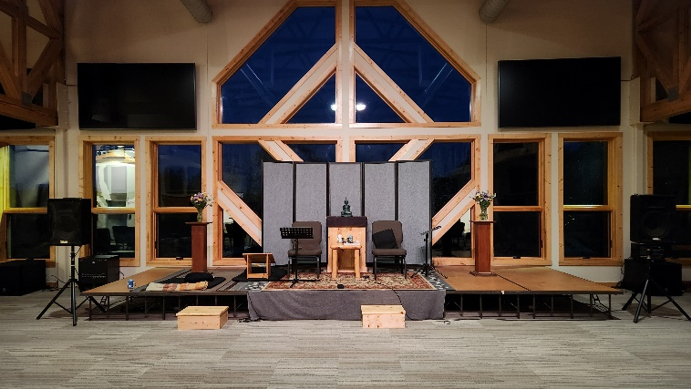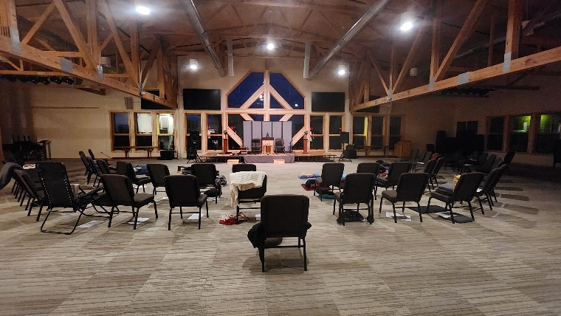

Set up the Audio
The microphones don’t require batteries. The Phantom Power switch on the mixer powers them.
There’s extra batteries in the TCVC red audio bag that could be used for the recording device and clocks, though these are generally replaced before coming to the retreat.
There are yogi jobs to turn the mixer on in the morning and off at the end of the night.
- Plug the speakers into the mixer
Set up the Koronis speakers to either side of the platform (see pictures next page)
Place the Koronis portable mixer behind and lateral to the left speaker
Connect speakers to the back of the mixer.
- Plug the Listening Assist system into the mixer
Put the Listening Assist black transceiver into the left side of the Listening Assist dock.
Connect the input on the left side of the dock to the Monitor output (lower right) on the mixer.
Plug in the Listening Device Charging Station on a chair in the lobby just outside the meditation hall.
- Plug the microphones into the mixer.
There are two TCVC lapel microphones in TCVC’s red bag along with two cords.
Use the cords to connect these mics to inputs 2 and 3 on the mixer.
Inputs 2 and 3 are marked WHITE and YELLOW on the lower left side of the front of the mixer.
- Set up the front of the mixer as pictured below
Turn ON the Phantom Power switch in the upper right corner. This powers the microphones.
Turn ON the Yamaha Speaker Processing switch below the Phantom Power on the right.
Turn ON the power to the mixer using the ON/OFF toggle in the lower right corner.
Adjust mixer dials from top to bottom clock position as follows: ~11:30, 10:00, 5:00, 8:00 and 11:30
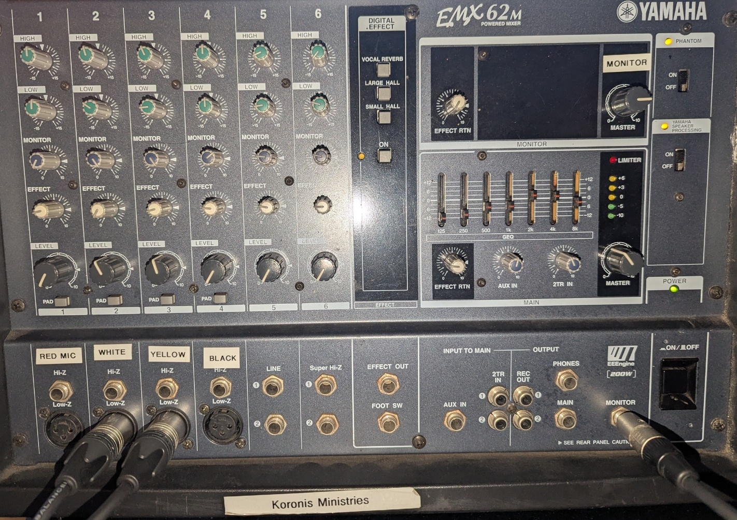

Test mics and listening system
Turn on the mics, using the low-cut ^ setting.
(Also ask the teachers to use this setting when they turn on the mics.)
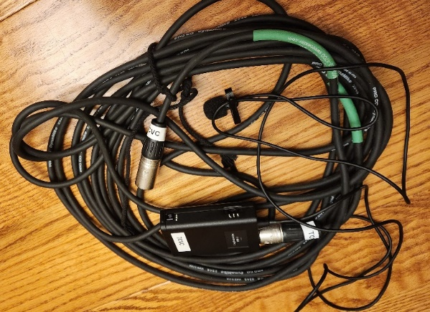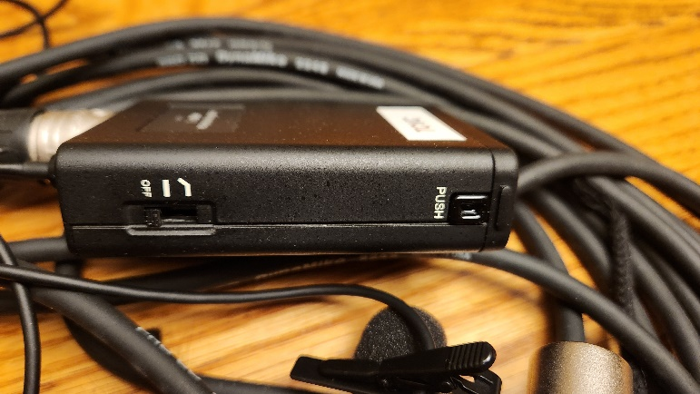
Here’s the placement of the listening devices and a diagram of the overall layout.
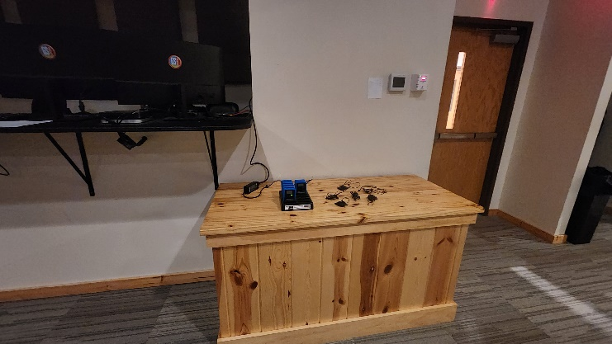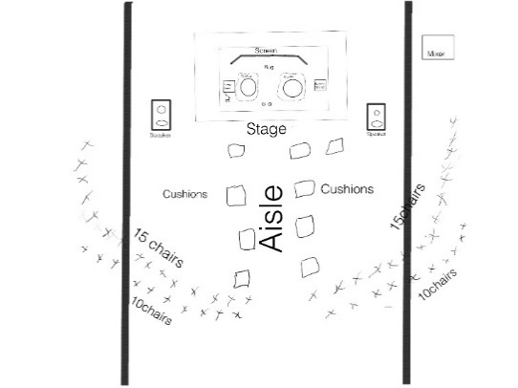

Set up Bulletin Board Area (Tabernacle)
Vestibule area outside the Meditation Hall
- Winter: set up coat rack (from Tabernacle or with TCVC supplies) and hangers
- Set up a large table for WATER BOTTLES behind the couch.
Set up a large table to the left of the Meditation hall door for the Bulletin Board table.
- Put the unscented soap bin and supply basket either on a table (as below) or on the wood chairs outside the meditation hall.
Put this sign on the table or wall by the unscented soap bin:
Help yourself to unscented soap, shampoo and conditioner…
Put this sign on the table or wall behind the supply basket: TCVC supplies, help yourself.
Summer: put of the Tick information sign along with a mirror, alcohol and tweezers as below.
Refrain from prefilling shampoo, conditioner, etc.—people like to fill these themselves so that they know what’s in the bottle.
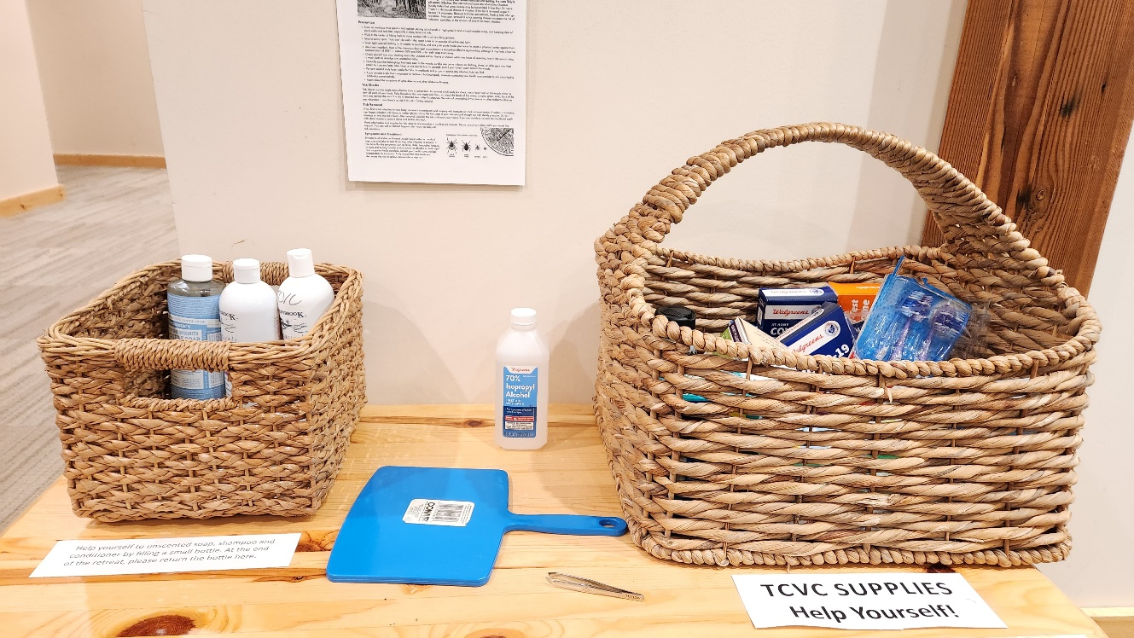
- Put two large Bronners soaps in each of the upstairs bathrooms along with TCVC soap signs on Koronis soap dispensers. (If necessary—one person may be doing all the soaps.)

Bulletin Board
- Lean the white board up against the wall on the bulletin board table with the short end on the table.
- Write the opening night schedule on the upper half of the board
Opening Night Schedule
6:00 supper
7:10 water/bell ringer orientation
7:30 retreat opens—noble silence begins
After opening talk: newcomer orientation
After opening night, the upper half of the board can be used for the yogi check-in schedule or other messages.
- Using the magnets found in the small supply bin, put the following signs on the lower half of the board.
ESSENTIAL MESSAGES
for Teachers
for Manager Put manager’s Room Number somewhere on the bulletin board
for Yogis from managers/teachers
Leave some extra magnets on the board for people to post their messages.
- Given the limited space on the board, post these on a nearby wall
Retreat schedule, Retreat Etiquette and Covid Safety Protocols, Where to Walk
Koronis facility and Trail Map
- The Bulletin Board table holds
- Clock, box of tissues, container with pens, pencils and note pads
- Summer: Sun block, bug spray and bug catcher
Winter cough drops (in blue basket) and body lotion
Large and small Burmese bells

Check In Room opposite Meditation Hall

- Teacher Check In sign (Teachers will decide which room they’ll use. Always utilize this room.)
- Arrange 5-7 chairs in a circle, depending on the number of people at the retreat
- Bring a small table from either the Lower Level Lakeview or the Tabernacle sitting area.
Put tissues and a clock on this table. (If a table is unavailable, use a chair.)
- Put the tray for teachers’ cups, dishwashing soap and scrubbing pad by the sink
(Train the people doing the yogi jobs who will be replenishing water prior to the opening so that the teachers’ cups are brought to the stage.)
- Put one small Bronners soap in the bathroom along with the TCVC soap sign on Koronis soap dispenser. (If necessary—one person may be doing all the soaps.)
- Optional: put a large table between the sink and the check-in area for the teachers to have their meals. Check with the teachers whether they would like to eat here or in the dining room.
At the end of the retreat
- Return the room to how it was originally, returning the small table to where it came from.
- Pack up the tray, dish soap, scrubbing pad into one of the grey filing cases.
- Return the unscented soap and sign to the plastic soap bin.

Dining Room (Lower Level Tabernacle)

- Post signs: Put a Noble Silence sign on the glass door opening into the dining room. On the back of this sign, put the Dining Etiquette sign. Post a schedule near the front door.
- Give the kitchen staff at least one copy of the Schedule.
- Put a “Reserved” sign on the teachers’ dining table (on other far side of the room) if they won’t be eating upstairs.
- Put one large Bronners soap in each of the two bathrooms along with TCVC soap sign on soap dispensers. (If necessary—one person may be doing all the soaps.)
- Put bell on the shelf above the coat rack just inside the front door

At the end of the retreat
- Retrieve the unscented soaps and signs and put back in the unscented soap bin.
Carefully remove the signs so that we can reuse. The schedules can be tossed.
- Bring the bell to the upper entrance of Tabernacle.

Set up Sunrise (Hotel)

Downstairs
- Signs: Walking Meditation and Schedule on wall outside 1st floor conference room. These are visible from the front door as you enter the building.
Optional Sign: Noble Silence
Summer: Tick information and bug catcher on entry table.
- 1st floor conference room: Ensure that both sides of the room are clear of chairs
- One small Bronners soap in each of two bathrooms along with TCVC soap signs on Koronis soap dispensers. (If necessary—one person may be doing all the soaps.)

2nd floor conference room if using for Teacher Check in
- Winter: Teacher Check In sign (Teachers will decide which room they’ll use.)
In the winter, the Lakeview Conference room is unsafe for some people with disabilities to walk due to snow and ice. While there is an elevator in Sunrise, it’s unusable. In the winter, the teachers will need to alternate between this room and the Tabernacle check in room to accommodate people unable to use the stairs.
Consider using the Sunrise 1st floor conference room for winter check ins. A small lamp or two can be borrowed from the resident rooms to make the space more ambient. Close the room divider to make the divide the space.
- Arrange 7 chairs in a circle
- Bring a small table from either the Lower Level Lakeview or the Tabernacle sitting area
Put tissues and a clock on this table. (If a table is unavailable, use a chair.)
When you’re through setting up
- Set aside the supply box somewhere out of site for the duration of the retreat.
- Bring the tape to the bulletin board table in Tabernacle. (Tape is scarce on opening day!)
At the end of the retreat
- Put back everything you set up to the way it was originally.
- Retrieve the unscented soaps and signs and put back in the unscented soap bin.
Carefully remove the signs so that we can reuse. The schedules can be tossed.
- Bring the box to the upper entrance of Tabernacle.

Set up Pine Lodge

Downstairs
- Signs: Yoga sign in large front window
- One small Bronners soap in one of the bathrooms.
TCVC soap sign on Koronis soap dispenser.
Upstairs
- Signs: Yoga, Retreat Schedule,
Optional: Noble Silence
Summer: Tick information and bug catcher
- Switch MEN bathroom sign to WOMEN
- Wake-up Bell for Pine Lodge
- Two large Bronners soaps in both bathrooms. TCVC soap signs on Koronis soap dispensers.
(If necessary—one person may be doing all the soaps.)

When you’re through setting up
- Set aside the supply box somewhere out of site for the duration of the retreat.
- Bring the tape to the check in desk in Lakeview. (Tape is scarce on opening day!)
At the end of the retreat
- Put back everything you set up to the way it was originally.
- Retrieve the unscented soaps and signs and put back in the unscented soap bin.
Carefully remove the signs so that we can reuse. The schedules can be tossed.
- Bring the box to the upper entrance of Tabernacle.

Set up Lakeview
Main Entry/1st floor
- Signs: Schedule
Optional: Noble Silence
Summer: Tick information and bug catcher (optional)
- Walking Meditation sign with arrow pointing downward on door leading into the residential area
- Walking Meditation sign halfway down this stairway to the lower level
- Wake up Bell for Lakeview. Put on a side table in front entry.
- Two large Bronners soap in both bathrooms. TCVC soap signs on Koronis soap dispensers.
(If necessary—one person may be doing all the soaps.)
- Summer: Teacher Check In sign (Teachers will decide which room they’ll use.)
2nd floor
- 2nd floor conference room: Yoga sign. Move furniture to the periphery for yoga.
- Two large Bronners soap in both bathrooms. TCVC soap signs on Koronis soap dispensers.
(If necessary—one person may be doing all the soaps.)
Lower Level
- Winter: This room is arranged for quilters to sew. Make slight adjustments to the tables to encourage walking toward and from the windows overlooking the lake
Summer: Koronis staff dismantle the quilter table set up for the summer season. This will be replaced by tables which are ideally aligned to facilitate walking meditation to and from the lake. Koronis staff will move in 6 metal folding chairs per table that are ideally stacked along the back wall until the end of the retreat.
- Winter: On the south-side entry leading directly into the lower level: “Use other door ” sign
- South-side vestibule leading into the lower level: Walking meditation and Schedule
- One small Bronners soap in both bathrooms. TCVC soap signs on Koronis soap dispensers.
- Headphone box for bell ringers
Summer: On the bench outside the south-side vestibule close to the Community Bell.
Winter: Inside the lower level of Lakeview, near the entrance closest to Community Bell.
Summer Only: Outdoors
- Put a Yoga sign near the fire ring on south end of lake front (#9 on map)
- Arrange the picnic tables in the patio outside the kitchen area so that people can do walking meditation to and from the lake
When you’re through setting up
- Set aside the supply box somewhere out of site for the duration of the retreat.
The manager may ask you to bring back to the Tabernacle bulletin board also.
- Bring the tape to the check in desk in Lakeview. (Tape is scarce on opening day!)
At the end of the retreat
- Put back everything you set up to the way it was originally.
- Retrieve the unscented soaps and signs and put back in the unscented soap bin if necessary.
Carefully remove the signs so that we can reuse. The schedules can be tossed.
- Bring the box to the upper entrance of Tabernacle.

Set up Teachers’ Rooms (Winter)
2nd floor Sunrise
Room #200 for Rebecca
- Bedding: Turquoise sheets and pillow cases, white blanket, turquoise quilt
- Small tea kettle
- Two cups, one each blue and cream, can put on placemat
- Oil heater*
- One small Bronners soap in the bathroom.
- Papers: Retreat schedule and spreadsheet with participants
Room #202 for Chas
- Bedding: Black and white sheets and pillow cases, white blanket, grey quilt
- Two cups, one each blue and cream, can put on placemat
- Oil heater*
- One small Bronners soap in the bathroom.
- Papers: Retreat schedule and spreadsheet with participants
When you’re through setting up
- Set aside suitcase and backpack somewhere out of site for the duration of the retreat.
At the end of the retreat
- Put the quilts and blankets back into the suitcase.
Gather the sheets into pillowcases to avoid overfilling the suitcase.
- Pack the tea kettle, cups, placemats into the small back pack.
- Bring the Bronners soaps, suitcase, backpack and oil heaters to upper entrance of Tabernacle.
* Please don’t let the oil heaters freeze. (Heating oil can freeze at around 16°F, which is colder than water's freezing point of 32°F. When frozen, heating oil turns into a gel-like wax that can damage your heating system.)

Set up Teachers’ Rooms (Summer)
There are three cottages that we’ll be using.
Ideally Koronis will leave one of the beds unmade in each cabin. (Koronis towels are fine.)
All three cabins should include
- Folder with a map of the facility, retreat schedule and spreadsheet with participants
- Small Bronners in the bathrooms. Small dish soaps in the kitchenettes.
General supplies for cabins:
- Bedding. There are queen beds in #64 and #66, twin beds in #68.
- Tea kettle
- Two cups, one each blue and cream, can put on placemat
Cottage #64
https://www.koronisministries.org/facilitydetail/cottage-64-18725086
This cabin is just off the main road and has one queen bed.
Bedding: Sheet set, white blanket and turquoise quilt.
Cottage #68
https://www.koronisministries.org/!JHY6oDdqA+1FR3pLM8LsaP0+q-vlTm3Q5Ca0b1e9RErRVKmMz4J1BmICtnCei-M6w
This cabin is below the main road, between #64 and #66. There are two small bedrooms, each with two twin beds.
Bedding for twin bed: sheet set, Mexican blanket and yellow quilt
Cottage #66
https://www.koronisministries.org/facilitydetail/cottage-66-14902973
This cabin is closest the lake. There are two bedrooms, each with a queen bed.
Bedding for queen bed: sheet set, white blanket and grey quilt.
When you’re through setting up
- Set aside suitcase and backpacks somewhere out of site for the duration of the retreat.
At the end of the retreat
- Put the quilts and blankets back into the suitcase.
Gather the sheets into pillowcases to avoid overfilling the suitcase.
- Pack the tea kettle, cups, placemats into the small back packs.
- Bring the small Bronners soaps and dish soaps to Tabernacle.
Set the suitcases, sheets and backpacks outside the upper cabin and load directly into a car.

Unscented Soaps
General Information
Fine print from Dr. Bronner’s label: “2-3x more concentrated than many leading liquid soaps… Dilute with water. Clouds when cold.” “Add 1 part soap to 3 parts water in foaming dispenser. Use within a month”. Diluting the soap with water prevents the caps on containers from getting clogged.
Please return all unused soap in its original bottle. A volunteer has offered the soap to TCVC and uses the leftovers.
Distributing the soap and soap signs at the retreat
Ideally the soap containers are prefilled before the retreat. Filling the bottles half-way, makes the soap lighter to carry, but requires that the volunteers top off each container at the retreat center.
If the bottle is already filled to the top, it is ready to distribute.
If the bottle is filled only half way, add water to fill the container to the top.
Tape the signs “This soap is scented. Please use TCVC unscented soaps provided” to the soap dispensers in every bathroom that you distribute to.
Distribute the soap bottles to the bathrooms as follows…
- Lakeview 6 baths using 8 large bottles and 2 small bottles
2nd floor: Women’s bath 2 large bottles Men’s bath: 2 large bottles
1st floor Women’s bath 2 large bottles Men’s bath: 2 large bottles
Lower level: Women’s bath 1 small bottle Men’s bath: 1 small bottle
- Tabernacle: 5 baths using 6 large bottles and 1 small bottle
Upper Level: Women’s bath 2 large bottles Men’s bath: 2 large bottles
Check in Room: 1 small bottle
Two Lower Level all-gender bathrooms: 1 large bottle in each bathrooms (2 total)
- Sunrise: 2 baths using 2 small bottles
Two Lower Level all-gender bathrooms: 1 small bottle in each bathroom (2 total)
- Pine Lodge: 2 baths using 2 large bottles and 2 small bottles
Upper Level: Women’s bath 1 large and 1 small is each bathroom
- Teacher’s rooms: 1 small bottle in each room (2-3 total)
Large: 8+6+2=16 (8 ounce bottles half strength = 64 ounces)
Small: 2+1+2+2+2=9 (4 ounce bottles half strength: 18 ounces)
Total 82 ounces: 2.5 32 ounce bottles
When you’re through distributing
- Bring the plastic bin that held the bottles to the bulletin board table in Tabernacle.
- Let the manager know whether you (ideally!) will be able to collect the soap bottles and soap signs at the end of the retreat. Bring back the soap bottles (with the unused soap) to the plastic bin which should be set up in Tabernacle. Other participants may also return soap. Your job is to check every bathroom to be sure the soap and the soap signs are returned.

Room Assignments
General Information
It’s best to assign rooms just a few days before the retreat to avoid rework due to registration changes.
Optional: There’s a spreadsheet that has the history of whether people had a lake view at Koronis on past retreats. Check this list to assign rooms based on where people have stayed in the past. If they didn’t have a lake view on a past retreat, they may enjoy a view on this retreat—and vice versa. This is especially important for board members so that the wider community has confidence that the board isn’t giving themselves extra perks at the expense of others.
You will need the Koronis Facility Floor Plans.
Ask the manager which room they would like to stay in—this is a perk for being manager.
Assigning rooms in the Sunrise Hotel
There are 19 rooms in the hotel. In the winter, only 16-17 rooms will be available for yogis, as 2-3 of these will be used by the teachers. (In the summer the teachers stay in cabins.)
- Teachers are usually assigned to rooms 200 and 202, with 204 for assistant.
- Sunrise has three handicap-accessible rooms on the first floor: 104, 106 and 110. Assign these rooms to anyone who has requested an accessible room.
- Rooms 101 and 103 have gotten bad reviews. Avoid assigning if possible.
- Room 209 has a king bed. It’s nice to let the person assigned to this room know about the king bed in case they prefer to use their own sheets. (Optionally, provide a king bottom sheet.)
- Because every room has a private bathroom, it’s not so important to segregate men from women in the hotel, but it’s a nice thing to do.
Assigning shared rooms in Lakeview and Pine Lodge
There are 31 rooms in Lakeview and 15 rooms on the 2nd floor of Pine Lodge. (We don’t use the 1st floor of Pine Lodge as it’s too musty.) In the summer, avoid assigning Room 107 in Lakevie as the window opens on to a moldy porch.
- If there are 31 people or less in shared rooms, only assign rooms in Lakeview. We usually fill the Lakeview facility first and assign a lesser number of people in Pine Lodge. If there’s a small number of people to be assigned to Pine Lodge and hotel rooms available, confer with the registrar/treasurer about putting people in the hotel so that Koronis need not prepare Pine Lodge for our use.
- Determine the total number of women and men in shared rooms. Usually there’s a greater number of women and Pine Lodge is filled with all women.
- Assign 1st floor rooms in Lakeview to those with accessibility requests.
- Lakeview Rooms 221 and 222 are in the family wing. These rooms have queen beds so either don’t assign or let the people staying there know the beds are queen if they bring sheets.
- Put an equal number of men on the 1st and 2nd floor of Lakeview. The men are usually assigned rooms on the end of the hall furthest from the bathrooms—unless they need greater accessibility to the bathroom on 1st floor.
- Fill in the rest of the rooms with the remaining women, usually closest to the bathrooms. The bathrooms on the 2nd floor are more spacious than the 1st floor, so it’s fine to have significantly more women on the 2nd floor.
- If someone is high on the wait list for a hotel room, don’t assign a room with a view.

Generate Retreat Spreadsheets
- Check in
This spreadsheet is usually sorted by First Name. 1st refers to whether this is their 1st retreat.
Notes can be used to indicate where this person is on the hotel room wait list.
Here |  | First Name | Last Name | Room | 1st | Phone | Notes
 |  | First | Last | LV-208 |  | 999-999-9999
- Teacher
Also sorted by First Name. Special could refer to a late arrival or other registration notes.
Leave the Notes columns blank for teacher use.
Notes |  | First Name | Last Name | Gender | 1st | Special | Room | Notes
 |  | First | Last | Female |  |  | LV-208
- Manager
Sorted by Room, this sheet is helpful if you need someone to switch rooms. It can also give you more information about a person in case someone needs a ride. Help indicates those that have volunteered. State is from their address.
Room | View | First Name | Last Name | Gender | 1st | Phone | Ride | Help | State | Special
LV-102 | NV | First | Last | BIPOC | Y | 999-999-9999 | I have | Y | MN | Accessible

