Volunteer Set Up Instructions

Contents

Set up Check In area 2

Check in instructions 3

Set up Meditation Hall (Tabernacle) 4

Set up the Audio 5

**Test mics and listening system** 6

**Minding the Audio system during the retreat** 6

**These pictures show the placement of the speakers and mixer.** 6

Set up Bulletin Board Area (Tabernacle) 7

Check In Room opposite Meditation Hall 8

Dining Room (Lower Level Tabernacle) 8

Set up Sunrise (Hotel) 9

**2nd floor conference room if using for Teacher Check in** 9

Set up Pine Lodge 10

Set up Lakeview 11

Set up Teachers’ Rooms (Winter) 12

Set up Teachers’ Rooms (Summer) 13

Unscented Soaps 14

# Set up Check In area

* Tape TCVC **Check In Here** signs in Lakeview outside entry  
    
  Tape **Check In Parking Here** signs by lot across the street from Lakeview   
   (unsure best spot—we haven’t posted these here before)
* Set up the first floor conference room with tables and chairs for people to fill out forms.  
  Put pens on each table and provide **Waiver** and **Bio Questionnaires.**
* Set up Registration area with two long tables with chairs behind for the check in people  
  — **Spreadsheet** with list of names with room numbers  
  — **Koronis Facility Map** and **Residential Floor Plans** to guide people to their rooms  
    
  — **Small schedules** with name/room/service job on back  
   (Sometimes check in volunteers prefill the names & room numbers)  
    
  — Service job signup sheets: **Bell Ringers, Practice Leaders** and **Yogi Jobs**Use tape for the signup sheets sparingly, as these sheets will be moved to the Bulletin board area in Tabernacle prior to the opening of the retreat.  
    
  — Handouts  
   **Retreat Etiquette/Covid Safety  
   Noble Silence**
* Two **Large Envelopes** to return…  
  — Waivers  
  — Bio Questionnaires
* Add our **Trail Maps** to the maps that Koronis provides on their shelf

# Check in instructions

* People must provide a signed Waiver of Liability and completed Bio Questionnaire in order to check in. If they haven’t printed these out at home, send them to the Conference Room to fill out.
* Put their signed **Waivers** and **Bio Questionnaires** in the designated **envelopes**.
* Check off their name on the **Checkin Spreadsheet**.
* Give people a **Small Schedule** with their name and room number  
  (Sometimes volunteers fill these out with the yogi names and room ahead of time.)
* Ask people to read the following handouts  
  **Etiquette** and **Covid Safety Protocols** on retreat (this is 2-sided)  
  **Handout on Noble Silence**
* Ask people if they would be willing to **Ring a Bell**, be a **Practice Leader** or do a **Yogi Job**.  
  Bell Ringer and Practice Leader most important to fill.  
  Post the **Bell Ringer and Practice Leader Instructions** nearby.   
    
  Bell ringer orientation is at 7:10PM. Meet at the big Community Bell on the south end of Lakeview (opposite end of the Checkin area.).
* People in dorm-style rooms need to pick up their bedding and towels  
  Lakeview: at the far end of the main entrance  
  Pine Lodge: first floor hallway
* Parking will be tight in the parking lot opposite Lakeview. Ask people to move their cars to the parking lots closer to Sunrise or Pine Lodge, if staying there. Ask people staying in Lakeview to move their cars to a lot further out to allow space for people coming in.

Cancellations

* If someone in ***Sunrise*** cancels, check the **Wait List** for the next person in line to get a room with a private bath and make this adjustment accordingly. Mark this on the spreadsheet.

Winding down

* Latecomers are inevitable. If someone is able to remain at the checkin desk over the supper hour, that is ideal. Leaving the table unattended is also OK. If unattended, do what you can to make the process as self-service friendly as possible.  
    
  Consider calling people who haven’t arrived by 6PM.
* After the opening, clear the Lakeview entry of the checkin setup, moving tables, chairs and all checkin materials to the 1st floor conference room.
* Winter: Ask Koronis attendant to take out their coat rack from the retail store area in the front entry. Let them know we brought out own hangers. Put the TCVC hangers on the rack. (This coat rack can also be moved to Tabernacle.)
* Summer: Take down the tables in the conference room and set up for teacher check in.

# Set up Meditation Hall (Tabernacle)

Some of the gear for set up is provided by Koronis. These items are pointed out in the notes—all other items are brought to the retreat center. See the Audio Gear section for a diagram of the set up.

**Stage**

* Put the large grey rug (Koronis storage room with entry through the check in room opposite meditation hall) in the center of the stage, with the long edge up to the front of the stage.
* Place cloth beneath the rug, hanging over the front of the stage as a skirt.
* Place stage steps on either side of the lateral edges of the rug at the front of the platform.
* Pace the flowers on either side of the screen. These can be placed on the higher lectern and tall thin table. Alternatively, use the lower end tables found in the Tabernacle lounge and also in lower level of Lakeview (See picture in the Audio Set Up)
* Arrange the teachers’ sitting cushions and chairs on the rug
* Set the TCVC lectern and Koronis music stand off to the side.  
  Put a copy of the **schedule** and **chants** on the lectern and music stand
* Put the TCVC meditation hall bell, a clock and microphones near the cushions.
* The teacher’s drinking cups will go here, but will need to be washed and filled first in the sink in the check in room opposite the meditation hall.
* Winter: container with candles and lighters for Chas

**Rest of the Hall**

* Put down some “guide cushions” so people have a sense of where the center aisle is and how close to be to the stage. You can use the cushions provided for people flying in, putting a “Reserved for <Yogi Name>” sign on top of the cushion.
* Set up a one or two chairs in front and off to the side for the teacher(s) to sit in when the other teacher is giving a dharma talk. Put **Reserved** signs on top of these chairs.
* Set up about 50 chairs around the back in a semi-circle, leaving a space down the middle for the aisle up to the stage. A first row with 30 chairs and a second row with 20 chairs is ideal.   
  (See diagram in the Audio section.)
* Set aside the handouts for the retreat. These are usually passed out at the opening  
  **Refuges and Precepts  
  Chant sheets**

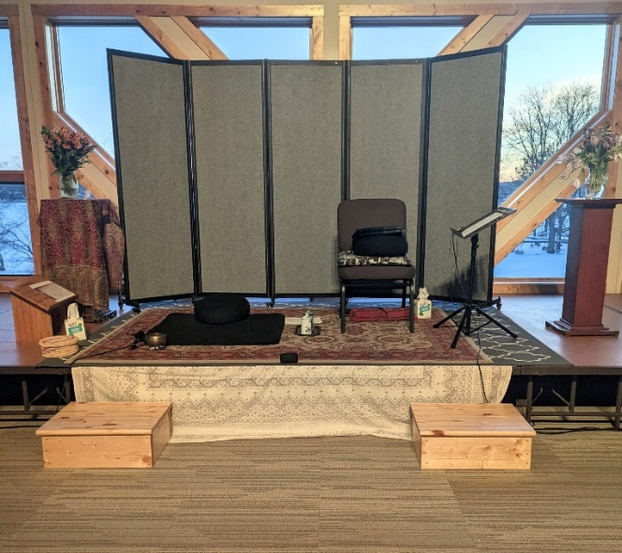 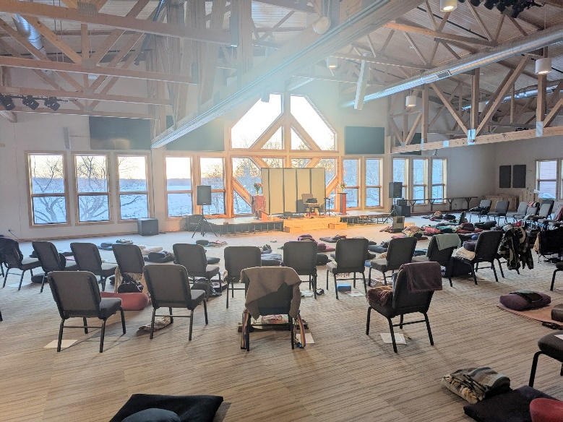

# Set up the Audio

The microphones don’t require batteries. The Phantom Power switch on the mixer powers them.  
There’s extra batteries in the TCVC red audio bag that could be used for the recording device and clocks, though these are generally replaced before coming to the retreat.

There are yogi jobs to turn the mixer on in the morning and off at the end of the night.

* **Plug the speakers into the mixer**  
  Set up the Koronis speakers to either side of the platform (see pictures next page)  
  Place the Koronis portable mixer behind and lateral to the left speaker  
  Connect speakers to the back of the mixer.
* **Plug the Listening Assist system into the mixer**  
  Put the Listening Assist black transceiver into the left side of the Listening Assist dock.   
  Connect the input on the left side of the dock to the **Monitor** output (lower right) on the mixer.  
  Plug in the Listening Device Charging Station on a chair in the lobby just outside the meditation hall.
* **Plug the microphones into the mixer.**   
  There are two TCVC lapel microphones in TCVC’s red bag along with two cords.   
  Use the cords to connect these mics to inputs 2 and 3 on the mixer.  
  Inputs 2 and 3 are marked WHITE and YELLOW on the lower left side of the front of the mixer.
* **Set up the front of the mixer as pictured below**  
  Turn ON the **Phantom Power** switch in the upper right corner. This powers the microphones.  
  Turn ON the **Yamaha Speaker Processing** switch below the **Phantom Power** on the right.  
  Turn ON the power to the mixer using the **ON/OFF** toggle in the lower right corner.

Adjust mixer dials from top to bottom clock position as follows: ~11:30, 10:00, 5:00, 8:00 and 11:30

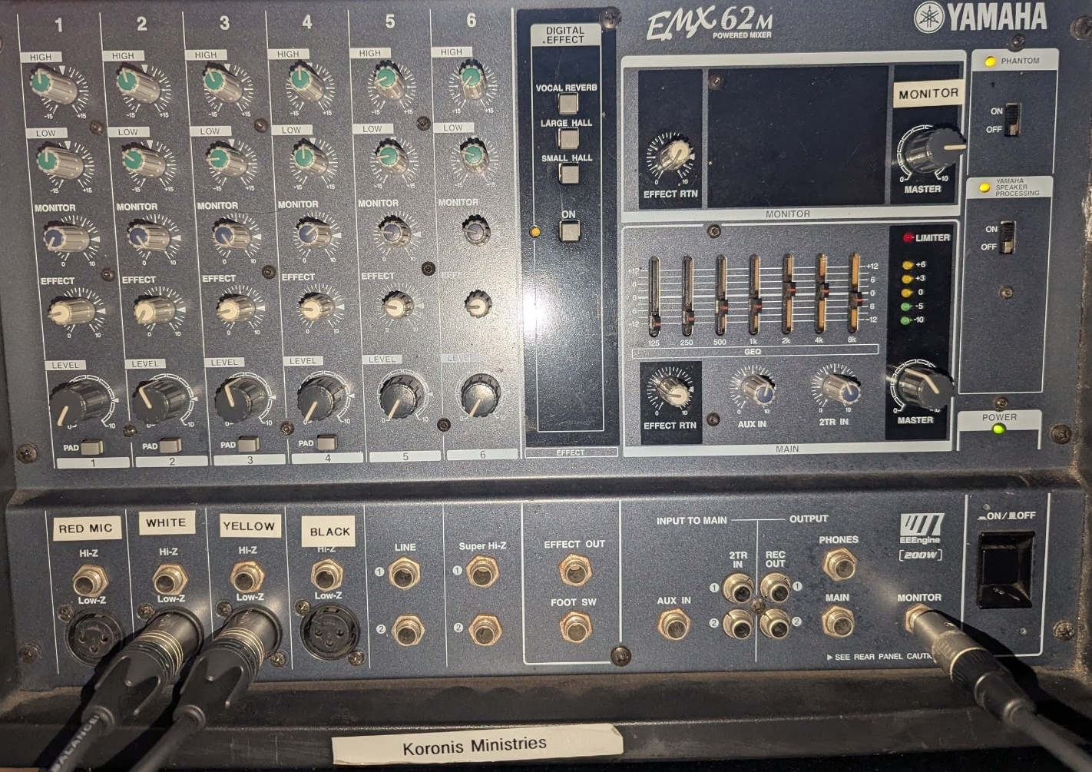

## **Test mics and listening system**

Turn on the mics, using the low-cut ^ setting.

(Also ask the teachers to use this setting when they turn on the mics.)

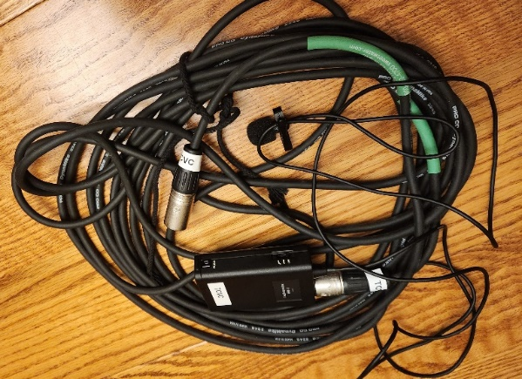 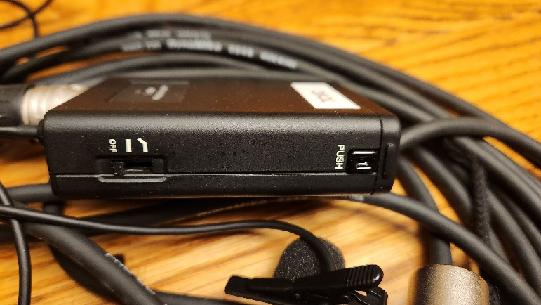

## **These pictures show the placement of the speakers and mixer.**

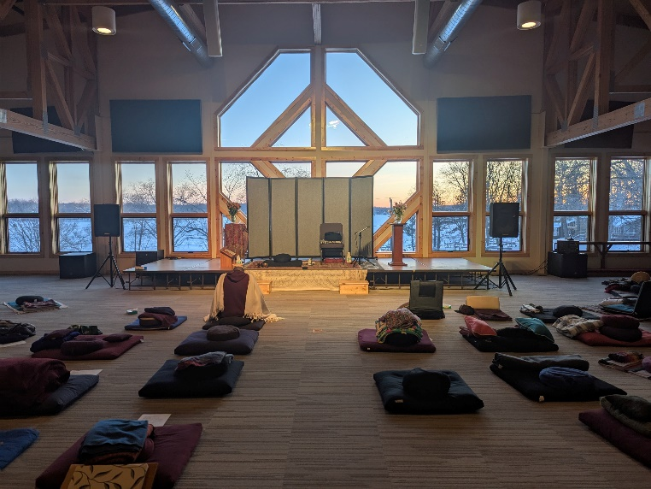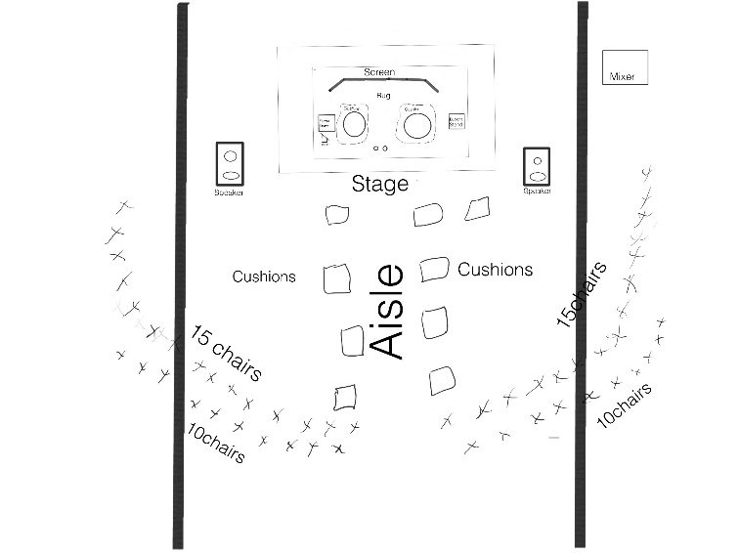

This picture shows the smaller tables with flowers. The reserved chair (on the far right) for the teacher can face the yogis or it can also face the stage closer to the other chairs.

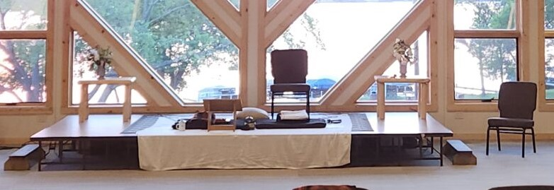

Notice the difference in the width of the stage. A larger stage better for 3 teachers.

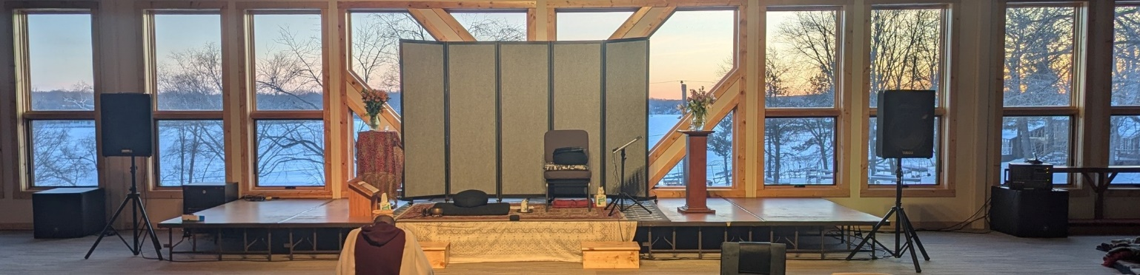

# Set up Bulletin Board Area (Tabernacle)

**Vestibule area outside the Meditation Hall**

* Winter: set up coat rack (from Tabernacle or with TCVC supplies) and hangers
* Set up a large table for **WATER BOTTLES** behind the couch.  
  Set up a large table to the left of the Meditation hall door for the Bulletin Board table.
* Put the supply basket, unscented soap bin and basket of empty containers on the chairs to the left of the fireplace next to the far wall.s  
  Tape this sign to the *wall behind the supply basket:* **TCVC supplies, help yourself**.  
  Tape this sign to the *wall behind the unscented soap bin and containers:***Help yourself to unscented soap, shampoo and conditioner…**
* Put the **Listening Device Charging Station** on the chairs to the left of the fireplace, closest to meditation hall entrance.
* Summer: Put the Tick station with tick information, mirror and tweezers near the listening devices
* Put two large Bronners soaps in each of the upstairs bathrooms along with TCVC soap signs on Koronis soap dispensers.

**Bulletin Board**

* Lean the white board up against the wall on the bulletin board table
* The left side of the white board is usually reserved for hand written announcements .  
  On opening day the evening schedule is typically posted here:   
  Opening Night Schedule  
   6:00 supper  
   7:10 water/bell ringer orientation  
   7:30 retreat opens—noble silence begins  
   After opening talk: newcomer orientation
* The right side of the white board usually holds messages, which are anchored by these small signs:

**ESSENTIAL MESSAGES   
 for Teachers  
 for Manager** Put manager’s Room Number somewhere on the bulletin board **for Yogis from managers/teachers**Leave some extra magnets on the board for people to post their messages.

* The list of yogis attending check in meetings will be posted on the bulletin board by the teachers  
  Given the limited space on the board, post these on a nearby wall **Retreat schedule, Retreat Etiquette** and **Covid Safety Protocols, Where to Walk**  
  **Koronis facility** and **Trail Maps**
* The Bulletin Board table holds

1. Clock, box of tissues, container with pens, pencils and note pads
2. Summer: Sun block, bug spray and bug catcher  
   Winter cough drops (in blue basket) and body lotion

Large and small Burmese bells

# Check In Room opposite Meditation Hall

* **Teacher Check In** sign (Teachers will decide which room they’ll use. Always utilize this room.)
* Arrange 7 chairs in a circle
* Bring a small table from either the Lower Level Lakeview or the Tabernacle sitting area  
  Put tissues and a clock on this table. (If a table is unavailable, use a chair.)
* Put the tray for teachers’ cups, teachers’ cups, dishwashing soap and scrubbing pad by the sink  
  (Train the people doing the yogi jobs who will be replenishing water prior to the opening so that the teachers’ cups are brought to the stage.)
* Put one small Bronners soap in the bathroom along with the TCVC soap sign on Koronis soap dispenser.

# Dining Room (Lower Level Tabernacle)

* Post signs: **Dining Etiquette, Schedule, Noble Silence**. Give the kitchen staff a **Schedule**.
* Put “**Reserved**” sign on the teachers’ dining table (on other side of room divider).
* Put one large and one small Bronners soap in each of the two bathrooms along with TCVC soap sign on soap dispensers.
* Put bell on the shelf above the coat rack just inside the front door

# Set up Sunrise (Hotel)

**Downstairs**

* Signs: **Noble Silence, Schedule**  
  Summer: **Tick information** and bug catcher (optional)
* 1st floor conference room: **Walking Meditation** signs on both doors  
  Ensure that both sides of the room are clear of chairs  
  Close off the kitchen areas if possible
* One large Bronners soap in each of two bathrooms along with TCVC soap signs on Koronis soap dispensers.

## **2nd floor conference room if using for Teacher Check in**

* **Winter: Teacher Check In** sign (Teachers will decide which room they’ll use.)  
  In the winter, the Lakeview Conference room is unsafe for some people with disabilities to walk due to snow and ice. While there is an elevator in Sunrise, it’s unusable. In the winter, the teachers will need to alternate between this room and the Tabernacle check in room to accommodate people unable to use the stairs.  
    
  This room could also be used in the summer instead of the 1st floor conference room in Lakeview.
* Arrange 7 chairs in a circle
* Bring a small table from either the Lower Level Lakeview or the Tabernacle sitting area  
  Put tissues and a clock on this table. (If a table is unavailable, use a chair.)

**When you’re through setting up**

* Set aside the supply box somewhere out of site for the duration of the retreat.
* Bring the tape to the bulletin board table in Tabernacle. (Tape is scarce on opening day!)

**At the end of the retreat**

* Put back everything you set up to the way it was originally.
* Retrieve the soaps and all signs and put back in the box.  
  Carefully remove the signs so that we can reuse. The schedules can be tossed.
* Bring the box to the bulletin board area in Tabernacle.

# Set up Pine Lodge

**Downstairs**

* Signs: **Yoga** sign in large front window
* One small Bronners soap in one of the bathrooms.  
  TCVC soap sign on Koronis soap dispenser.

**Upstairs**

* Signs: **Yoga, Retreat Schedule, Noble Silence**  
  Summer: **Tick information** and bug catcher (optional)**Ti**
* Switch **MEN** bathroom sign to **WOMEN**
* Wake-up Bell for Pine Lodge
* One large and one small Bronners soap in both bathrooms.  
  TCVC soap signs on Koronis soap dispensers.

**When you’re through setting up**

* Set aside the supply box somewhere out of site for the duration of the retreat.
* Bring the tape to the check in desk in Lakeview. (Tape is scarce on opening day!)

**At the end of the retreat**

* Put back everything you set up to the way it was originally.
* Retrieve the soaps and all signs and put back in the box.  
  Carefully remove the signs so that we can reuse. The schedules can be tossed.
* Bring the box to the bulletin board area in Tabernacle.

# Set up Lakeview

**Main Entry/1st floor**

* Signs: **Schedule, Noble Silence**Summer: **Tick information** and bug catcher (optional)
* **Walking Meditation sign with arrow** pointing downward on door leading into the residential area
* **Walking Meditation** sign halfway down this stairway to the lower level
* Wake up Bell for Lakeview
* One large and one small Bronners soap in both bathrooms.  
  TCVC soap signs on Koronis soap dispensers.
* **Summer: Teacher Check In** sign (Teachers will decide which room they’ll use.)  
  It would be possible for the teachers to use the 2nd floor room in Sunrise also

**2nd floor**

* 2nd floor conference room: **Yoga** sign. Move furniture to the periphery for yoga.
* One large and one small Bronners soap in both bathrooms w/soap signs on soap dispensers.

**Lower Level**

* **Walking Meditation sign** and **Schedule** in main walking room
* The room is arranged for quilters to sew. Make slight adjustments to the tables to encourage walking toward and from the windows overlooking the lake
* On the south-side entry leading directly into the lower level: “**Use other door 🡪**” sign
* South-side vestibule leading into the lower level:  **Walking meditation** and **Schedule**
* Set up some tables near both entries for people to put their **WATER BOTTLES**
* One small Bronners soap in both bathrooms.   
  TCVC soap signs on Koronis soap dispensers.
* Headphone box for bell ringers  
  Summer: On the bench outside the south-side vestibule close to the Community Bell.   
  Winter: Inside the lower level of Lakeview, near the entrance closest to Community Belll.

**Summer Only: Outdoors**

* Put a **Yoga** sign near the fire ring on south end of lake front (#9 on map)
* Arrange the picnic tables in the patio outside the kitchen area so that people can do walking meditation to and from the lake

**When you’re through setting up**

* Set aside the supply box somewhere out of site for the duration of the retreat.  
  The manager may ask you to bring back to the Tabernacle bulletin board also.
* Bring the tape to the check in desk in Lakeview. (Tape is scarce on opening day!)

**At the end of the retreat**

* Put back everything you set up to the way it was orginally.
* Retrieve the soaps and all signs and put back in the box.  
  Carefully remove the signs so that we can reuse. The schedules can be tossed.
* Bring the box to the bulletin board area in Tabernacle.

# Set up Teachers’ Rooms (Winter)

**2nd floor Sunrise**

**Room #200 for Rebecca**

* Bedding: Turquoise sheets and pillow cases, white blanket, turquoise quilt
* Small tea kettle
* Two cups, one each blue and cream, can put on placemat
* Oil heater*
* One small Bronners soap in the bathroom.
* Papers: Retreat schedule and spreadsheet with participants

**Room #202 for Chas**

* Bedding: Black and white sheets and pillow cases, white blanket, grey quilt
* Two cups, one each blue and cream, can put on placemat
* Oil heater*
* One small Bronners soap in the bathroom.
* Papers: Retreat schedule and spreadsheet with participants

**When you’re through setting up**

* Set aside suitcase and backpack somewhere out of site for the duration of the retreat.

**At the end of the retreat**

* Put the quilts and blankets back into the suitcase.   
  Gather the sheets ***into pillowcases.***
* Pack the tea kettle, cups, placemats into the small back pack.
* Bring the small Bronners soaps, suitcase, backpack and oil heaters to upper level of Tabernacle.

* Please don’t let the oil heaters freeze. (Heating oil can freeze at around 16°F, which is colder than water's freezing point of 32°F. When frozen, heating oil turns into a gel-like wax that can damage your heating system.)

# Set up Teachers’ Rooms (Summer)

There are three cottages that we’ll be using. I’m familiar with #64 and #68, but not #66 which is closest to the lake.

In 2024 the cottages were clean, but a bit cluttered. The decks were full of leaves and in general disarray. Bedding is provided by Koronis, but it’s our tradition to bring cotton sheets and bedding for the teachers. Ideally Koronis will leave one of the beds unmade in each cabin. (Koronis towels are fine.)

All three cabins should include

* Folder with a map of the facility, retreat schedule and spreadsheet with participants
* Small Bronners in the bathrooms

General supplies for cabins:

* Bedding. There are queen beds in #64 and #66, twin beds in #68.
* Tea kettle
* Two cups, one each blue and cream, can put on placemat

**Cottage #64**https://www.koronisministries.org/facilitydetail/cottage-64-18725086

This cabin is just off the main road and has one queen bed.

Bedding: Queen turquoise sheets and pillow cases, white blanket, turquoise quilt. (Because the bedroom is pretty small, assume that there aren’t extra blankets lying around. We can also get extra wool blankets from the 1st floor Lakeview storage room.)

**Cottage #68**https://www.koronisministries.org/!JHY6oDdqA+1FR3pLM8LsaP0+q-vlTm3Q5Ca0b1e9RErRVKmMz4J1BmICtnCei-M6w

This cabin is below the main road, between #64 and #66. There are two small bedrooms, each with two twin beds.

Bedding for twin bed: green floral sheets and yellow quilt

**Cottage #66**https://www.koronisministries.org/facilitydetail/cottage-66-14902973

This cabin is closest the lake. The website shows just one bedroom with what looks like a queen bed. This is the largest of the three cabins, but possibly the least desirable.

Bedding for queen (?) bed: grey sheet set and grey quilt.

**When you’re through setting up**

* Set aside suitcase and backpacks somewhere out of site for the duration of the retreat.

**At the end of the retreat**

* Put the quilts and blankets back into the suitcase.   
  Gather the sheets ***into pillowcases***.
* Pack the tea kettle, cups, placemats into the small back packs.
* Bring the small Bronners soaps to Tabernacle.   
  Set the suitcases, sheets and backpacks **outside the upper cabin and load directly into a car.**

# Unscented Soaps

It’s best to clean and fill the soap bottles prior to arriving at the retreat. The Bronner’s concentrated soap can be diluted at least 1:1 ahead of time, or optionally fill the soap bottles half full and fill to the top when distributing to the bathrooms at the center.

Prepare a large bottle of diluted soap for the soap/shampoo basket outside the meditation hall. This large soap will be used for refilling during the retreat and may need to be replenished by the manager.

The soaps can be distributed along with the signs or one person can set up all the soaps/signs and ideally take them down again. Regardless of how the soap was distributed, have a volunteer check all the bathrooms to ensure all the soaps and signs are returned at the end of the retreat.

Near the end of the retreat when the soaps are (ideally) running low, soap can be harvested from lightly used bathrooms such as lower level bathrooms of the residence halls.

The soaps are distributed to the following bathrooms. Tape the signs “This soap is scented. Please use TCVC unscented soaps provided” to the soap dispensers.

* Lakeview (6 rooms): 2 baths on lower level, 2 on 1st floor, 2 on 2nd floor = 4 large, 6 small
* Pine Lodge (3 rooms): 2 baths upstairs plus one of the downstairs baths = 2 large, 3 small
* Sunrise (2 rooms): 2 baths main floor = 2 large (Soaps aren’t distributed to the rooms.)
* Tabernacle (5 rooms): 2 baths on main floor, 3 baths upstairs = 6 large, 3 small
* Teachers (2 or 3 rooms) = 2-3 small

Large: 4 +2 + 2 + 6 = 16  
Small: 6 +3+3 + 2-3 = 14-15

The diluted soaps separate in a weird way, so usually the leftovers are returned to Joanne who uses up for laundry soap and cleans the containers for the next retreat. It’s possible that the soaps could be reused from the winter retreat for the summer retreat.